**RAJALAKSHMI ENGINEERING COLLEGE**

**RAJALAKSHMI NAGAR, THANDALAM – 602 105**



|  |
| --- |
| **CS23221**  **PYTHON PROGRAMMING LAB** |
| **Laboratory Observation Note Book** |

# Name: JEIYA SATHVIHAA.A

# Year/Branch/Section: 1-year /AI&DS-B

# Register No: 2116231801070

# Semester: 2nd Semester

# Academic Year: 2023­ - 2024

# 

**INDEX**

**Reg. No. :2116231801070 Name : JEIYA SATHVIHAA A**

**Year : 1 year Branch :AI&DS Sec : A**

|  |  |  |  |  |
| --- | --- | --- | --- | --- |
| **S.**  **No.** | **Date** | **Title** | **Page**  **No.** | **Teacher’s Signature /**  **Remarks** |
| **Introduction to python-Variables-Datatypes-Input/Output-Formatting** | | | | |
| 1.1 | **12.03.24** | Converting Input Strings | **8** |  |
| 1.2 | **12.03.24** | Gross salary | **10** |  |
| 1.3 | **12.03.24** | Square Root | **11** |  |
| 1.4 | **12.03.24** | Gain percent | **12** |  |
| 1.5 | **12.03.24** | Deposits | **14** |  |
| 1.6 | **12.03.24** | Carpenter | **16** |  |
| **Operators in Python** | | | | |
| 2.1 | **06.04.24** | Widgets and Gizmos | **19** |  |
| 2.2 | **06.04.24** | Doll Sings | **20** |  |
| 2.3 | **06.04.24** | Birthday party | **22** |  |
| 2.4 | **06.04.24** | Hamming Weight | **24** |  |
| 2.5 | **06.04.24** | Compound Interest | **25** |  |
| 2.6 | **06.04.24** | Eligible to donate blood | **26** |  |
| 2.7 | **06.04.24** | C or D | **28** |  |
| 2.8 | **06.04.24** | Troy Battle | **30** |  |
| 2.9 | **06.04.24** | Tax and Tip | **32** |  |
| 2.10 | **06.04.24** | Return last digit of the given number | **34** |  |
| **Selection Structures in Python** | | | | |
| 3.1 | **12.04.24** | Admission eligibility | **37** |  |
| 3.2 | **12.04.24** | Classifying triangles | **40** |  |
| 3.3 | **12.04.24** | Electricity Bill | **42** |  |
| 3.4 | **12.04.24** | IN/OUT | **45** |  |
| 3.5 | **12.04.24** | Vowel or Constant | **47** |  |
| 3.6 | **12.04.24** | Leap Year | **49** |  |
| 3.7 | **12.04.24** | Month name to Days | **52** |  |
| 3.8 | **12.04.24** | Pythagorean triple | **54** |  |
| 3.9 | **12.04.24** | Second Last Digit | **56** |  |
| 3.10 | **12.04.24** | Chinese Zodiac | **58** |  |
| **Algorithmic Approach: Iteration Control Structures** | | | | |
| 4.1 | **13.04.24** | Factors of a Number | **61** |  |
| 4.2 | **13.04.24** | Non-Repeated Digits Count | **63** |  |
| 4.3 | **13.04.24** | Prime Checking | **64** |  |
| 4.4 | **13.04.24** | Next Perfect Square | **66** |  |
| 4.5 | **13.04.24** | Nth Fibonacci | **67** |  |
| 4.6 | **13.04.24** | Disarium Number | **69** |  |
| 4.7 | **13.04.24** | Sum of Series | **70** |  |
| 4.8 | **13.04.24** | Unique Digits Count | **72** |  |
| 4.9 | **13.04.24** | Product of single digits | **73** |  |
| 4.10 | **13.04.24** | Perfect Square After adding One | **75** |  |
| **Strings in Python** | | | | |
| 5.1 | **17.04.24** | Count chars | **78** |  |
| 5.2 | **17.04.24** | Decompress the String | **79** |  |
| 5.3 | **17.04.24** | First N Common Characters | **80** |  |
| 5.4 | **17.04.24** | Remove Characters | **82** |  |
| 5.5 | **17.04.24** | Remove Palindrome Words | **84** |  |
| 5.6 | **17.04.24** | Return Second Word in Uppercase | **85** |  |
| 5.7 | **17.04.24** | Reverse String | **87** |  |
| 5.8 | **17.04.24** | String characters balance Test | **88** |  |
| 5.9 | **17.04.24** | Unique Names | **89** |  |
| 5.10 | **17.04.24** | Username Domain Extension | **90** |  |
| **List in Python** | | | | |
| 6.1 | **04.05.24** | Monotonic array | **93** |  |
| 6.2 | **04.05.24** | Check pair with difference k . | **96** |  |
| 6.3 | **04.05.24** | Count Elements | **98** |  |
| 6.4 | **04.05.24** | Distinct Elements in an Array | **101** |  |
| 6.5 | **04.05.24** | Element Insertion | **104** |  |
| 6.6 | **04.05.24** | Find the Factor | **107** |  |
| 6.7 | **04.05.24** | Merge list | **111** |  |
| 6.8 | **04.05.24** | Merge Two Sorted Arrays Without Duplication | **114** |  |
| 6.9 | **04.05.24** | Print Element Location | **117** |  |
| 6.10 | **04.05.24** | Strictly increasing | **124** |  |
| **Tuples & Set** | | | | |
| 7.1 | **18.05.24** | Binary String | **126** |  |
| 7.2 | **18.05.24** | Check Pair | **131** |  |
| 7.3 | **18.05.24** | DNA Sequence | **133** |  |
| 7.4 | **18.05.24** | Print repeated no | **136** |  |
| 7.5 | **18.05.24** | Remove repeated | **138** |  |
| 7.6 | **18.05.24** | malfunctioning keyboard | **141** |  |
| 7.7 | **18.05.24** | American keyboard | **143** |  |
| **Dictionary** | | | | |
| 8.1 | **25.05.24** | Uncommon Words | **145** |  |
| 8.2 | **25.05.24** | Sort Dictionary By Values Summation | **149** |  |
| 8.3 | **25.05.24** | Winner Of Election | **151** |  |
| 8.4 | **25.05.24** | Student Record | **154** |  |
| 8.5 | **25.05.24** | Scramble Score | **156** |  |
| **Functions** | | | | |
| 9.1 | **01.06.24** | Abundant Number | **158** |  |
| 9.2 | **01.06.24** | Automorphic number or not | **161** |  |
| 9.3 | **01.06.24** | Check Product of Digits | **166** |  |
| 9.4 | **01.06.24** | Christmas Discount | **169** |  |
| 9.5 | **01.06.24** | Coin Change | **170** |  |
| 9.6 | **01.06.24** | Difference Sum | **171** |  |
| 9.7 | **01.06.24** | Ugly number | **172** |  |
| **Searching & Sorting** | | | | |
| 10.1 | **01.06.24** | Merge Sort | **173** |  |
| 10.2 | **01.06.24** | Bubble Sort | **174** |  |
| 10.3 | **01.06.24** | Peak Element | **175** |  |
| 10.4 | **01.06.24** | Binary Search | **176** |  |
| 10.5 | **01.06.24** | Frequency of Numbers | **177** |  |
| **Expection Handling** | | | | |
| 11.1 | **02.06.24** | Exception Handling-1 | **178** |  |
| 11.2 | **02.06.24** | Exception Handling-2 | **180** |  |
| 11.3 | **02.06.24** | Exception Handling-3 | **181** |  |
| 11.4 | **02.06.24** | Exception Handling-4 | **183** |  |
| 11.5 | **02.06.24** | Exception Handling-5 | **185** |  |
| **Modules** | | | | |
| 12.1 | **07.06.24** | Representing unique pairs | **187** |  |
| 12.2 | **07.06.24** | Calculating average | **190** |  |
| 12.3 | **07.06.24** | Using dictionary | **191** |  |
| 12.4 | **07.06.24** | Power of four | **193** |  |
| 12.5 | **07.06.24** | Determining the total revenue | **195** |  |

**01 - Introduction to Python-Variables-Datatypes**

**Input/Output-Formatting**

**Ex. No. : 1.1 Date: 12.03.24**

**Register No.: 231801070 Name: JEIYA SATHVIHAA.A**

[**Converting Input Strings**](https://www.rajalakshmicolleges.net/moodle/mod/quiz/view.php?id=6373)

Write a program to convert strings to an integer and float and display its type.

*Sample Input:*

10

10.9

*Sample Output:*

10,<class 'int'>

10.9,<class 'float'>

**For example:**

| **Input** | **Result** |
| --- | --- |
| 10  10.9 | 10,<class 'int'>  10.9,<class 'float'> |

**Program:**

a=int(input())

print(a,end=",")

print(type(a))

b=float(input())

print(round(b,1),end=",")

print(type(b)

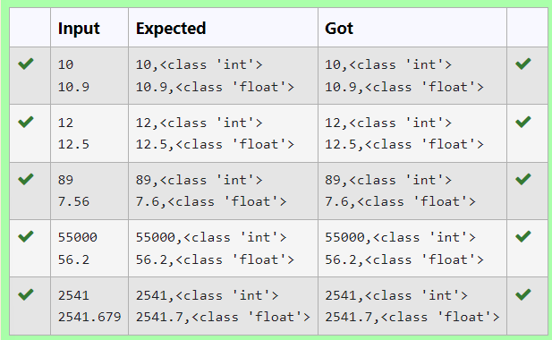

**Ex. No. : 1.2 Date: 12.03.24**

**Register No.: 231801070 Name:JEIYA SATHVIHAA.A**

[**Gross Salary**](https://www.rajalakshmicolleges.net/moodle/mod/quiz/view.php?id=6374)

Ramesh’s basic salary is input through the keyboard. His dearness allowance is 40% of his basic salary, and his house rent allowance is 20% of his basic salary. Write a program to calculate his gross salary.

*Sample Input:*

10000

*Sample Output:*

16000

**For example:**

| **Input** | **Result** |
| --- | --- |
| 10000 | 16000 |

**Program:**

a=int(input())

b=a*0.6

print(round(a+b))

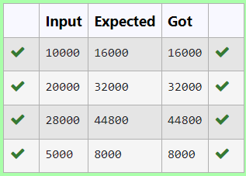

**Ex. No. : 1.3 Date: 12.03.24**

**Register No.: 231801070 Name: JEIYA SATHVIHAA A**

**Square Root**

Write a simple python program to find the square root of a given floating point number. The output should be displayed with 3 decimal places.

Sample Input:

8.00

Sample Output:

2.828

**For example:**

| **Input** | **Result** |
| --- | --- |
| 14.00 | 3.742 |

**Program:**

import math

a=float(input())

b=math.sqrt(a)

print(format(b,".3f"))

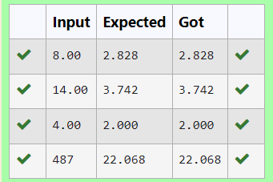

**Ex. No. : 1.4 Date: 12.03.24**

**Register No.: 231801079 Name: JEIYA SATHVIHAA.A**

[**Gain percent**](https://www.rajalakshmicolleges.net/moodle/mod/quiz/view.php?id=6376)

Alfred buys an old scooter for Rs. X and spends Rs. Y on its repairs. If he sells the scooter for Rs. Z (Z>X+Y). Write a program to help Alfred to find his gain percent. Get all the above-mentioned values through the keyboard and find the gain percent.

Input Format:

The first line contains the Rs X

The second line contains Rs Y

The third line contains Rs Z

Sample Input:

10000

250

15000

Sample Output:

46.34 is the gain percent.

**For example:**

| **Input** | **Result** |
| --- | --- |
| 45500  500  60000 | 30.43 is the gain percent. |

**Program:**

a=int(input())

b=int(input())

c=int(input())

d=a+b

e=c-d

f=(e/d)*100

print(format(f,".2f"),"is the gain percent.")

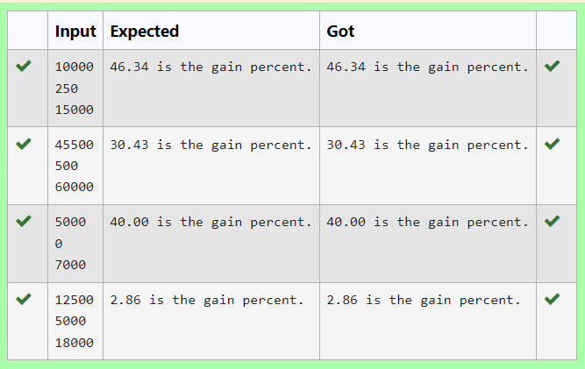

**Ex. No. : 1.5 Date: 12.03.24**

**Register No.: 231801070 Name: JEIYA SATHVIHAA A**

[**Deposits**](https://www.rajalakshmicolleges.net/moodle/mod/quiz/view.php?id=6378)

In many jurisdictions, a small deposit is added to drink containers to encourage people to recycle them. In one particular jurisdiction, drink containers holding one liter or less have a $0.10 deposit and drink containers holding more than one liter have a $0.25 deposit. Write a program that reads the number of containers of each size(less and more)  from the user. Your program should continue by computing and displaying the refund that will be received for returning those containers. Format the output so that it includes a dollar sign and always displays exactly two decimal places.

Sample Input

10

20

Sample Output

Your total refund will be $6.00.

**For example:**

| **Input** | **Result** |
| --- | --- |
| 20  20 | Your total refund will be $7.00. |

**Program:**

a=int(input())

b=int(input())

c=a*0.1+b*0.25

print("Your total refund will be $",format(c,".2f"),".",sep="")

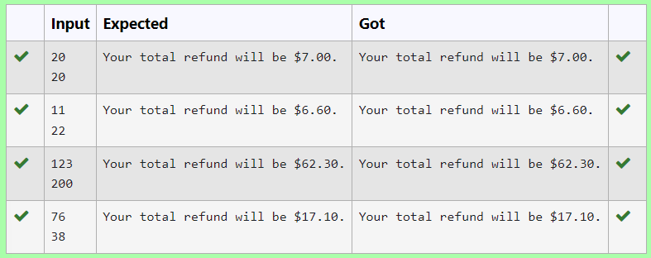

**Ex. No. : 1.6 Date: 12.03.24**

**Register No.: 231801070 Name: JEIYA SATHVIHAA A**

[**Carpenter**](https://www.rajalakshmicolleges.net/moodle/mod/quiz/view.php?id=6379)

Justin is a carpenter who works on an hourly basis. He works in a company where he is paid Rs 50 for an hour on weekdays and Rs 80 for an hour on weekends. He works 10 hrs more on weekdays than weekends. If the salary paid for him is given, write a program to find the number of hours he has worked on weekdays and weekends.

**Hint:**

If the final result(hrs) are in -ve convert that to +ve using abs() function

The abs() function returns the absolute value of the given number.

number = -20

absolute_number = abs(number)

print(absolute_number)

# Output: 20

**Sample Input:**

450

**Sample Output:**

weekdays 10.38

weekend 0.38

**For** exam**ple:**

| **Input** | **Result** |
| --- | --- |
| 450 | weekdays 10.38  weekend 0.38 |

**Program:**

a=int(input())

b=((500-a)/130)

b=abs(b)

c=b+10

print("weekdays",format(c,".2f"))

print("weekend",format(b,".2f"))

